Flamingo – Part B

Keen on 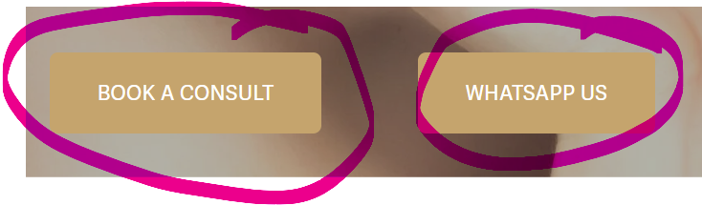

After you have added SKIN and IV THERAPY On here –
- SKIN
Should break into 2 once opened
SKIN
CSo the structure should be:
Aesthetics
CryoPen

CryoPen

❄️ What is CryoPen?
CryoPen is an advanced, precision device that uses a fine jet of nitrous oxide to freeze and destroy unwanted skin lesions quickly and safely.
Unlike traditional freezing methods, CryoPen delivers targeted cryotherapy, meaning:
- 🎯 Only the lesion is treated (minimal impact on surrounding skin)
- ⚡ Fast treatment (seconds per lesion)

🧊 What is Cryotherapy?
Cryotherapy is a treatment that uses extreme cold temperatures to freeze and remove abnormal or unwanted tissue.
When applied to skin:
- The cold causes the lesion cells to crystallise and break down
- The body naturally eliminates the damaged tissue
- Healthy skin gradually replaces it

✨ What Can It Treat?
CryoPen is ideal for a wide range of benign (non-cancerous) skin lesions, including:
- 🟤 Skin tags
- 🌿 Warts & verrucas
- ☀️ Sun spots (age spots)
- 🔴 Cherry angiomas
- 🟡 Milia
- 🧬 Seborrhoeic keratosis
- 🧷 Pigmented spots
✔️ Safe
✔️ Effective
✔️ Clinically proven

Key Benefits
Why clients are choosing CryoPen:
- ⚡ Quick treatments – often under 30 seconds
- 🎯 Precision targeting – no unnecessary damage
- 🩹 Minimal discomfort – no invasive procedures
- 🕒 No downtime – return to daily life immediately
- 🌱 Natural healing – skin regenerates over time
- 💎 Excellent cosmetic results

Why Choose CryoPen?
- 🔬 Medical-grade accuracy
- 🧠 Operator-controlled precision
- 🧴 No cutting, no stitches, no scarring (when done correctly)
- 📈 High client satisfaction

SKIN LESION

Minor Skin Lesion Assessment & Removal - MUST

- Skin lesion heading
- Photo
- Drop-down option containing the full content/details

For the skin lesion section, please also add a pricing reference. I would prefer not to display a fixed price. Instead, please state:

- Consultation fee: £50.
- The full treatment price will depend on the size of the skin lesion and the clinician’s assessment, including how many treatments may be required.
- If the patient proceeds with treatment, the £50 consultation fee will be deducted from the final treatment cost.
PRESENTATION -To Match Similar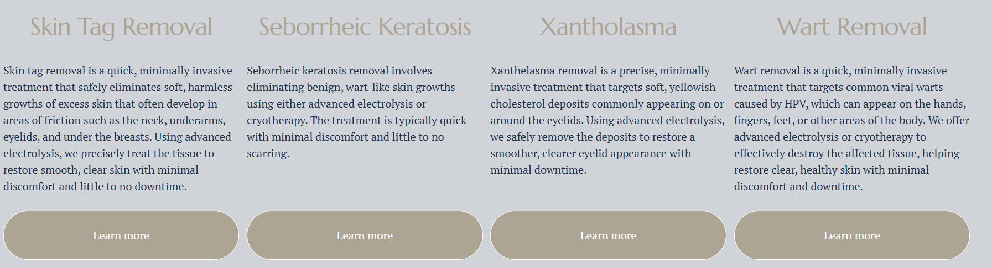
Add Photo of the condition – Attached on doc
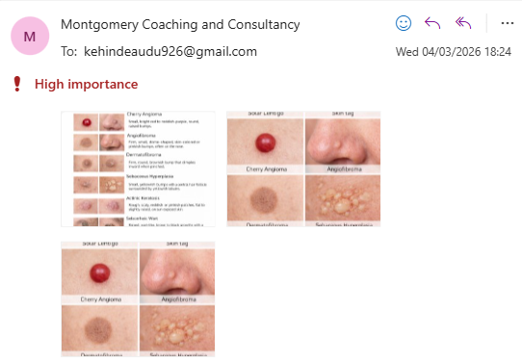

Treatments to be listed for SKIN

Pricing is based on the type, number, and size of lesions.
A consultation is therefore advised.
- Lentigines (pigmented spots, solar lentigo, age spots, liver spots) – from 8 lesions
- Skin Tags (Acrochordon)
- Milia (milk spots)
- Cherry Angioma (Cherry haemangioma, Campbell de Morgan spots) – from 14 lesions
- Ephelis / Ephelides (freckles)
- Actinic Keratosis (solar keratosis)
- Seborrhoeic Keratosis (basal cell papilloma, senile wart, brown wart)
- Sebaceous Hyperplasia
Acne Treatments
Treatments tailored to calm breakouts, improve texture and support clearer skin long-term. We will recommend the right plan after assessing your skin.

Consultation
- Consultation required for pricing: £50
- No consultation fee if you proceed with treatment
Specialist Skin Assessment
- Skin lesion check by a consultant dermatologist: £100
- Results provided within 48 hours



Presentation should be similar to
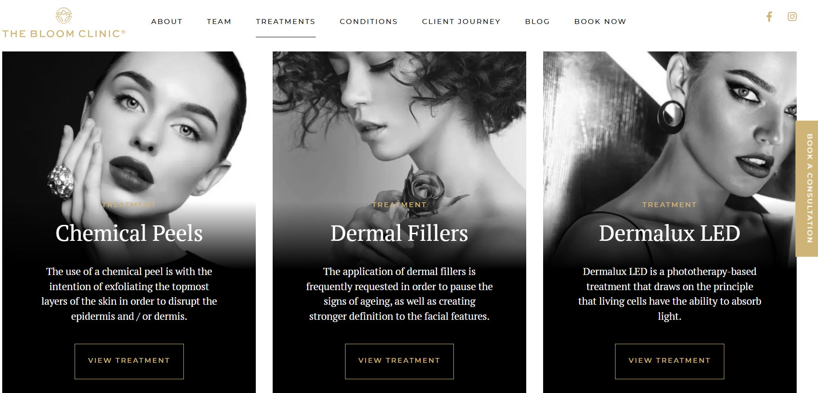

Listing
Our Aesthetic & Wellness Treatments
At Flamingo Medical & Wellness, we offer safe, clinician-led treatments designed to help you look refreshed and feel confident with natural results and a personalised approach.

✨ Dermal Fillers
Dermal fillers add volume, shape and definition to areas of the face where it’s needed. We use medical-grade hyaluronic acid (HA) fillers with lidocaine for comfort.
Cheeks – 1ml
£180.00 • 30 mins
Cheek Enhancement (1ml+)
Cheek filler helps lift and define the mid-face. We place filler at supportive levels to restore volume and gently improve the cheek contour for a fresher look.
Results are immediate and may last 9–18 months, depending on your skin and lifestyle.

Dermal Filler Dissolving
£100.00 • 45 mins
If you’ve had filler you’re unhappy with such as migration, lumps, asymmetry or overfilling we can dissolve it using hyaluronidase (an enzyme that breaks down HA filler).
We start with a consultation and patch test where appropriate, then carefully dissolve the filler in the area. Improvements are often seen within 24–48 hours, with short-term swelling or redness possible.
Once the area has settled, we can plan a refill or resculpt if desired.

Jaw – 2ml
£240.00 • 25 mins
Jawline Contouring (1ml+)
Jawline filler helps define and shape the lower face for a sharper, more balanced profile. It can support weak contours and improve symmetry without surgery.
Our HA filler is designed to hold structure while still looking natural and feeling comfortable.

Lips – 0.5ml
£90.00 • 30 mins
Lip Enhancement (0.5ml)
Ideal for a subtle boost. Adds hydration, soft definition and gentle volume while keeping lips natural and in proportion to your face.

Lips – 1ml
£180.00 • 30 mins
Lip Enhancement (1ml)
For fuller volume, improved shape and better symmetry. We tailor the result to your features so your lips still look like you just more defined and hydrated.

Marionette Lines – 1ml
£180.00 • 25 mins
Marionette Lines (1ml)
Targets the lines that run from the corners of the mouth toward the chin. This can soften shadows, support the lower face and create a more refreshed, lifted look.

✨ Anti-Wrinkle Treatments
Anti-wrinkle injections soften expression lines by relaxing overactive muscles. Our style is natural and refreshed, not “frozen”.
Areas we can treat (what they mean):
- Forehead lines: horizontal lines across the forehead
- Frown lines: the “11” lines between the brows
- Crow’s feet: fine lines at the outer corners of the eyes
- Bunny lines: small creases at the sides of the nose
- Lip lines: fine vertical lines above the lip
- Chin dimpling: pebbled/orange-peel texture on the chin
- Downturned mouth: corners of the mouth pulling downward
- Masseter: jaw clenching/teeth grinding and jaw slimming
- Neck bands: vertical neck lines that can become more visible with age
Anti-Wrinkle Treatment – 2 Areas
£190.00 • 20 mins
A great option for a subtle refresh. Two areas are usually forehead + frown, or frown + crow’s feet. Results typically last up to 4 months.
Anti-Wrinkle Treatment – 3 Areas
£210.00 • 30 mins
A more complete treatment for the main expression lines — typically forehead, frown and crow’s feet. We tailor placement to your facial muscles for balanced, natural movement.

Additional Anti-Wrinkle Options
Brow Lift – £60.00 • 20 mins
Gently lifts the brow by relaxing the muscles that pull it down, helping eyes look more open and refreshed.
Bunny Lines – £60.00 • 20 mins
Softens nose lines that appear when you smile or scrunch your nose.
Chin Dimpling – £60.00 • 20 mins
Smooths the chin for a softer, more even finish.
Downturned Mouth – £60.00 • 20 mins
Lifts the corners of the mouth for a less tired or sad expression.
Excess Sweating (Hyperhidrosis) – £450.00 • 30 mins
A popular treatment for excessive underarm/facial sweating. Results can last up to 6 months.
Lip Flip – £60.00 • 30 mins
A subtle enhancement where the top lip gently rolls outward, giving a slightly fuller look without filler.
Masseters (Jaw Slimming / Teeth Grinding) – £180.00 • 30 mins
Helps reduce clenching/grinding and can slim the jaw over time.
Migraines – £250.00 • 30 mins
A clinician-led protocol for suitable patients experiencing chronic migraines.
Neck Bands (Nefertiti Lift) – £200.00 • 30 mins
Softens neck bands and can improve jaw/neck definition for a smoother profile.
Nose Slimming – £80.00 • 20 mins
A non-surgical option to refine the nose tip/shape in selected cases.
Botox Top-Up Appointment – 30 mins
If needed, we review your result after 14 days (when the treatment has fully settled) and make small adjustments. Not everyone requires a top-up.
Vertical Lip Lines (Smoker’s Lines) – £60.00 • 30 mins
Micro-doses can soften fine lines around the mouth while keeping natural movement.

HAIR LOSS – Must be on Aesthetics
Hair loss is highly individual and it changes over time. The earlier the cause is understood and addressed, the better the long-term results. Our clinician-led approach focuses on identifying what’s driving your hair changes and creating a precise, targeted plan to protect and strengthen your hair.

Detailed Clinical Assessment
Every patient starts with a clinician-led evaluation to identify the type and cause of hair loss. This ensures your treatment is based on evidence, not assumptions.

PRP Therapy
We use high-concentration platelet-rich plasma to support follicle activity and improve scalp condition. This treatment can enhance hair quality and encourage healthier growth where follicles remain active.

Evidence-Based Medical Options
Where appropriate, we prescribe treatments shown to stabilise ongoing loss and protect existing hair. These may be used alone or in combination with PRP for a more comprehensive approach.

Bespoke Treatment Programmes
Your clinician designs a tailored programme based on your pattern of hair loss, expected response, and goals. Your plan is refined over time to keep treatment effective and results meaningful.

What You Can Expect
Many patients experience:
- A noticeable slowdown in ongoing hair thinning
- Improved density, strength, and overall hair quality
- Healthier growth in areas where follicles remain active
- Better long-term preservation of existing hair

Why Early Treatment Matters
Hair loss progresses gradually, and once follicles become inactive, regrowth becomes significantly more challenging. Early intervention gives you the strongest chance of maintaining and improving your hair over time.

Weight-Management Pathway
Our clinician-led weight management programme uses Mounjaro (tirzepatide) to support safe, effective, and sustainable weight loss.
Designed for individuals struggling with weight management, this treatment works by helping to:
- 🍽️ Reduce appetite and cravings
- ⏳ Slow gastric emptying (helping you feel fuller for longer)
- ⚖️ Support gradual, consistent weight loss

What’s Included
- ✔️ Full medical consultation
- ✔️ Personalised treatment plan
- ✔️ Ongoing clinical support
- ✔️ Lifestyle and nutrition guidance

⚠️ Important Information
- Treatment is only prescribed following a clinical assessment
- Suitable for individuals who meet specific medical criteria
- Regular monitoring ensures safe and effective results

Pricing
• 2.5mg – £200
• 5mg – £250
• 7.5mg – £320

